1. **Von Neumann architecture**

Von Neumann architecture is the base of modern computer which programs and data are stored in a separate storage unit called memories and are treated the same. This make computer much easier to reprogram. There are three basic components :

1. The Central Processing Unit (CPU)
2. The Main Memory Unit
3. The Input/Output Device
4. **Stored Program concept**

A stored-program computer is a [computer](https://en.wikipedia.org/wiki/Computer) that stores [program instructions](https://en.wikipedia.org/wiki/Instruction_(computer_science)) in electronically or optically accessible memory. When at before, systems that stored the program instructions with [plugboards](https://en.wikipedia.org/wiki/Plugboard) or similar mechanisms.

1. Preprocess with gcc -E first.c

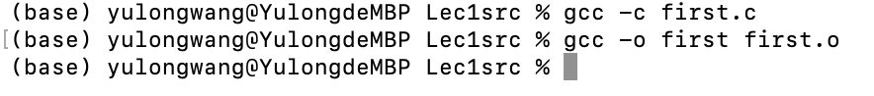

1. printf("main: a = %d, b = %d, argc = %d\n", a, b, argc);

It works like printf in java. Where the three %d was replaced by a,b,argc. And then the whole string is output to std.